**INTRODUCTION**

FASHION REDEFINED WITH VIRTUAL GROOMING & SHOPPING ASSISTANT

**OVERVIEW:**

In this modern era, everybody wants to be dressed up in a way that reflects ‘Swag.’ Evidently, your nature decides who you are, not your clothes. But at the same time, there is no loss in raising your fashion standard. At the present time, celebrities are setting the trend. For example, Megan Fox has a fantastic dressing sense, which is more than enough to make the hearts of her fans skip a beat. Believe it or not, girls are always more concerned about their attire as compared to boys. This could be the prime reason why girls take extra hours while shopping. With time, millennial shoppers consider e-commerce platforms a perfect place to buy clothes due to more variety. However, online shopping isn’t as easy as it sounds. Usually, customers are confronted by issues related to size, availability, et c. To overcome such problems, the fashion industry is using applications of artificial intelligence. Because of AI, nowadays, people are enjoying an amazing shopping experience.

**PURPOSE:**

AI and Machine Learning pave a new domain of possibilities in the Fashion industry, from Data Analytics to Fashion Chatbot as your personal stylists. You can leverage chatbot technology to your fashion industry which will have the following benefits

* Chatbots recommends products to a user based on their preferences
* By virtue of visual search, it gets easy to reach the desired clothes. All you need to do is take a picture of your preferred garment and upload it online to know about its availability
* Similar to voice assistants, virtual personal stylists are also out there to help you while shopping for some trendsetting clothes.

**PROPOSED SOLUTION:**

To make e-commerce shopping experience easier we propose creating a chatbot that can **:**

* Easily study patterns from the interaction that the bot made with a user.
* Analyse and comprehend the context of the chat, to predict a user’s preferences and interests.
* know what style of outfit a user intends to purchase.
* Dig its database to find the right match depending on user preferences.
* Can continuously throw different questions to users and keep them engaged to gain access to user details about their choices.
* Implement image analysis to recommend the perfect outfit according to the user’s physique and style preferences.
* Implement Virtual search to display the desired apparels.

**BLOCK DIAGRAM:**

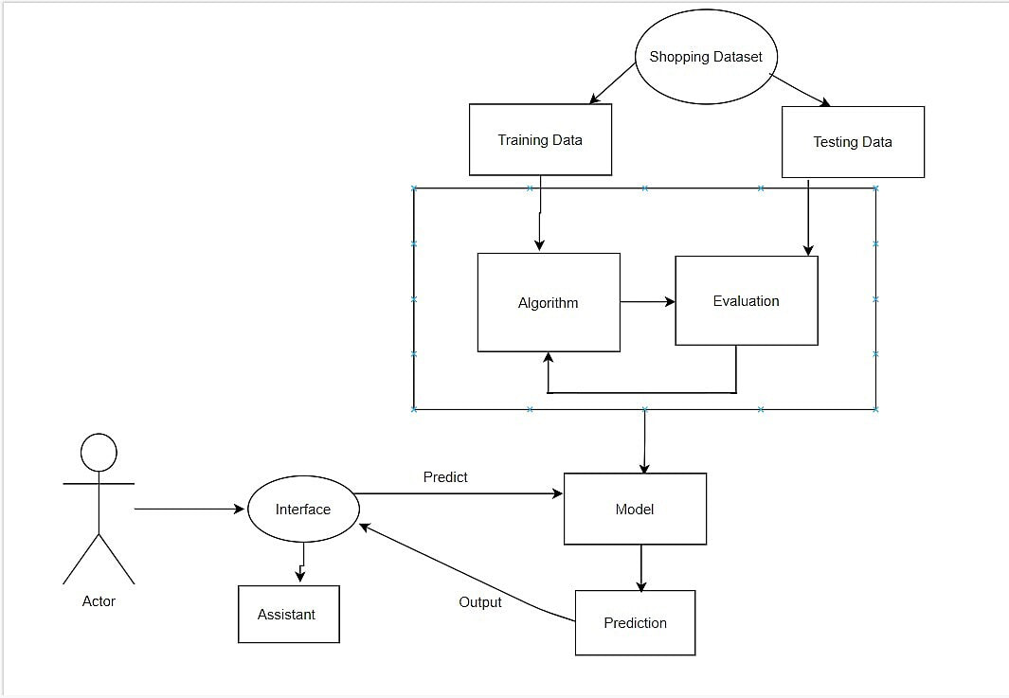

**FLOW CHART**

**BUILDING MACHINE LEARNING MODEL WITH IBM**

**BUILD A CHATBOT**

**INTEGRATING CHAT BOT WITH PYTHON SDK**

**INTEGRATIND DEEP LEARNING WITH FLASK**

**INTEGRATING CHATBOT TO WEBPAGE**

**RESULT:**

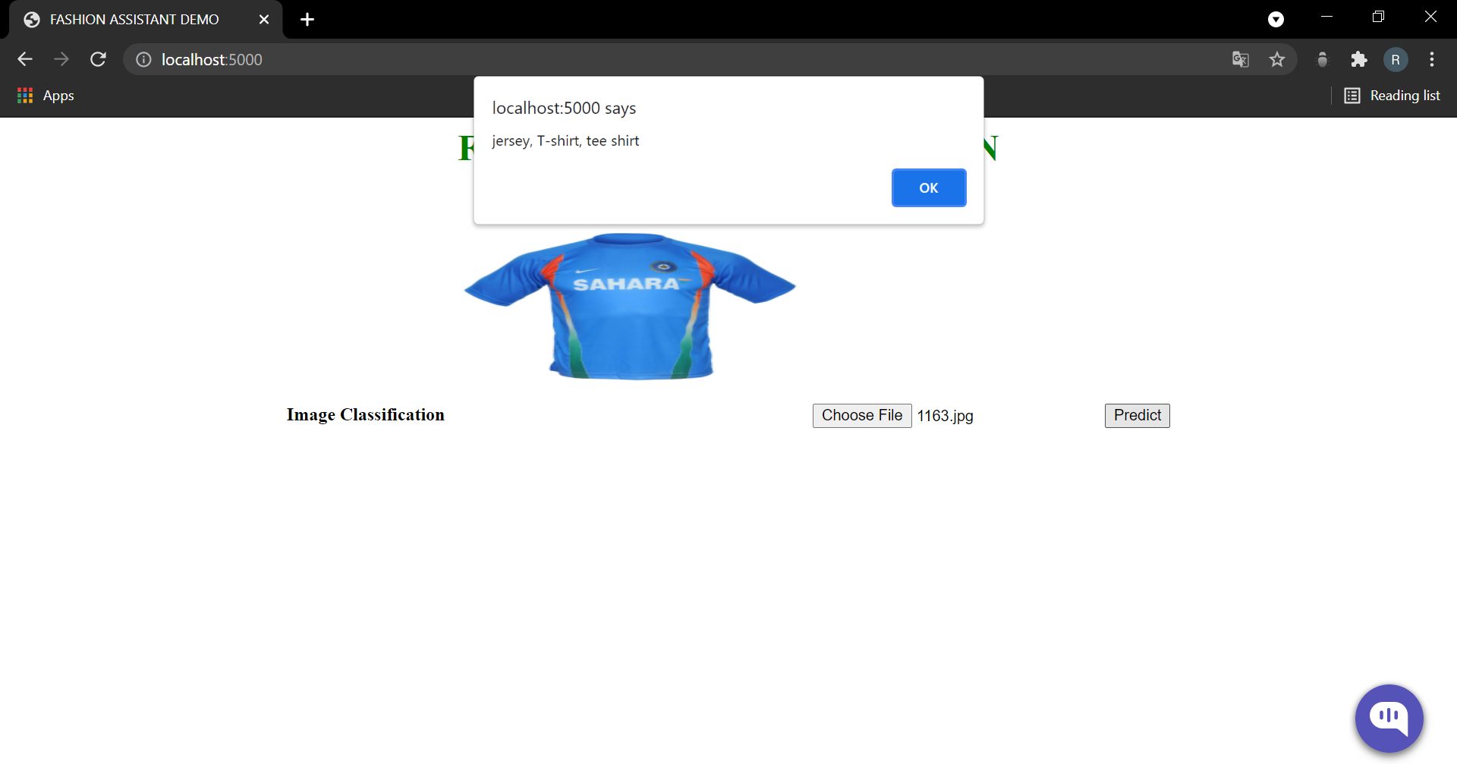

**THERE ARE VARIOUS CATEGORIES USER CAN ASK FOR ,**

**HERE IS THE DEMO FOR ONE OF THE CATEGORY WHICH IS "CASUAL".**

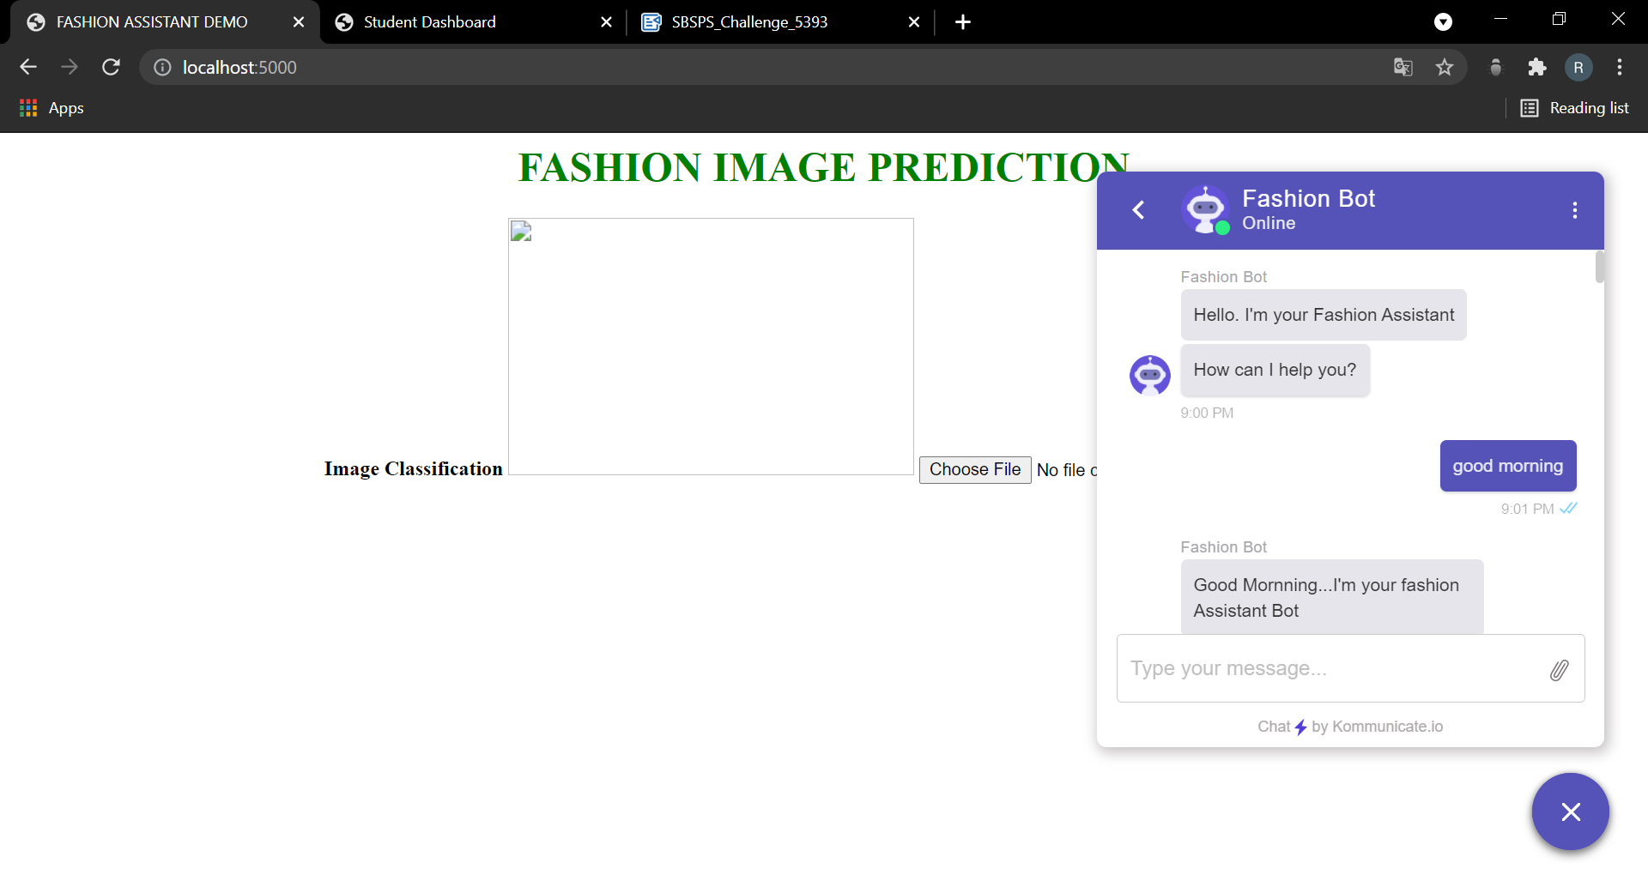

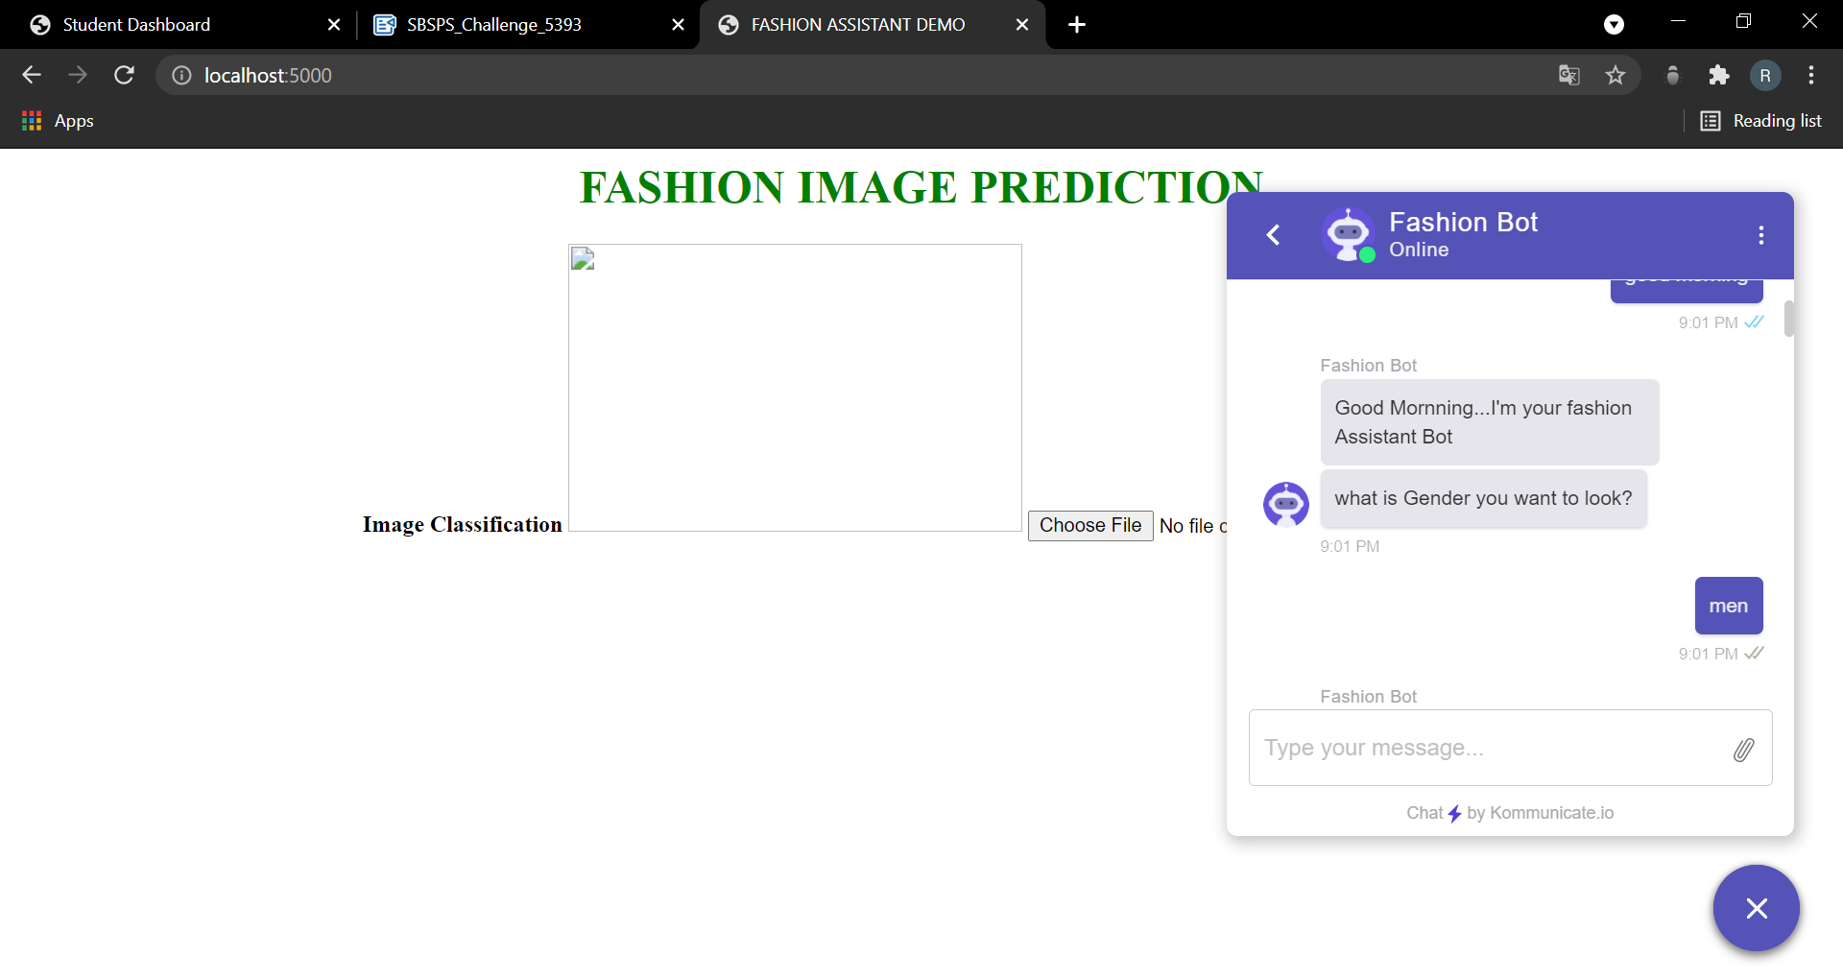

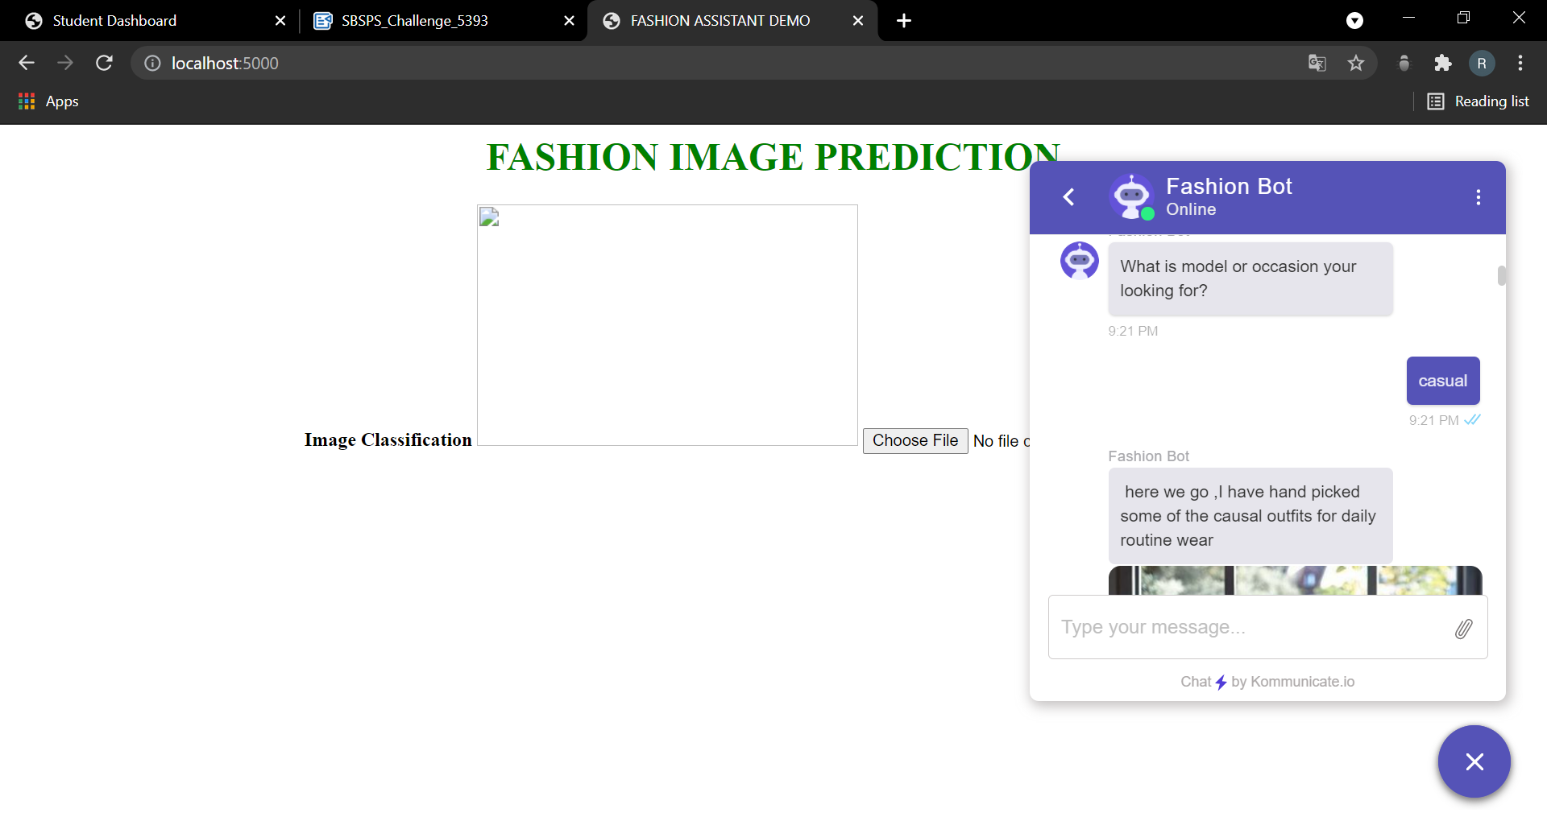

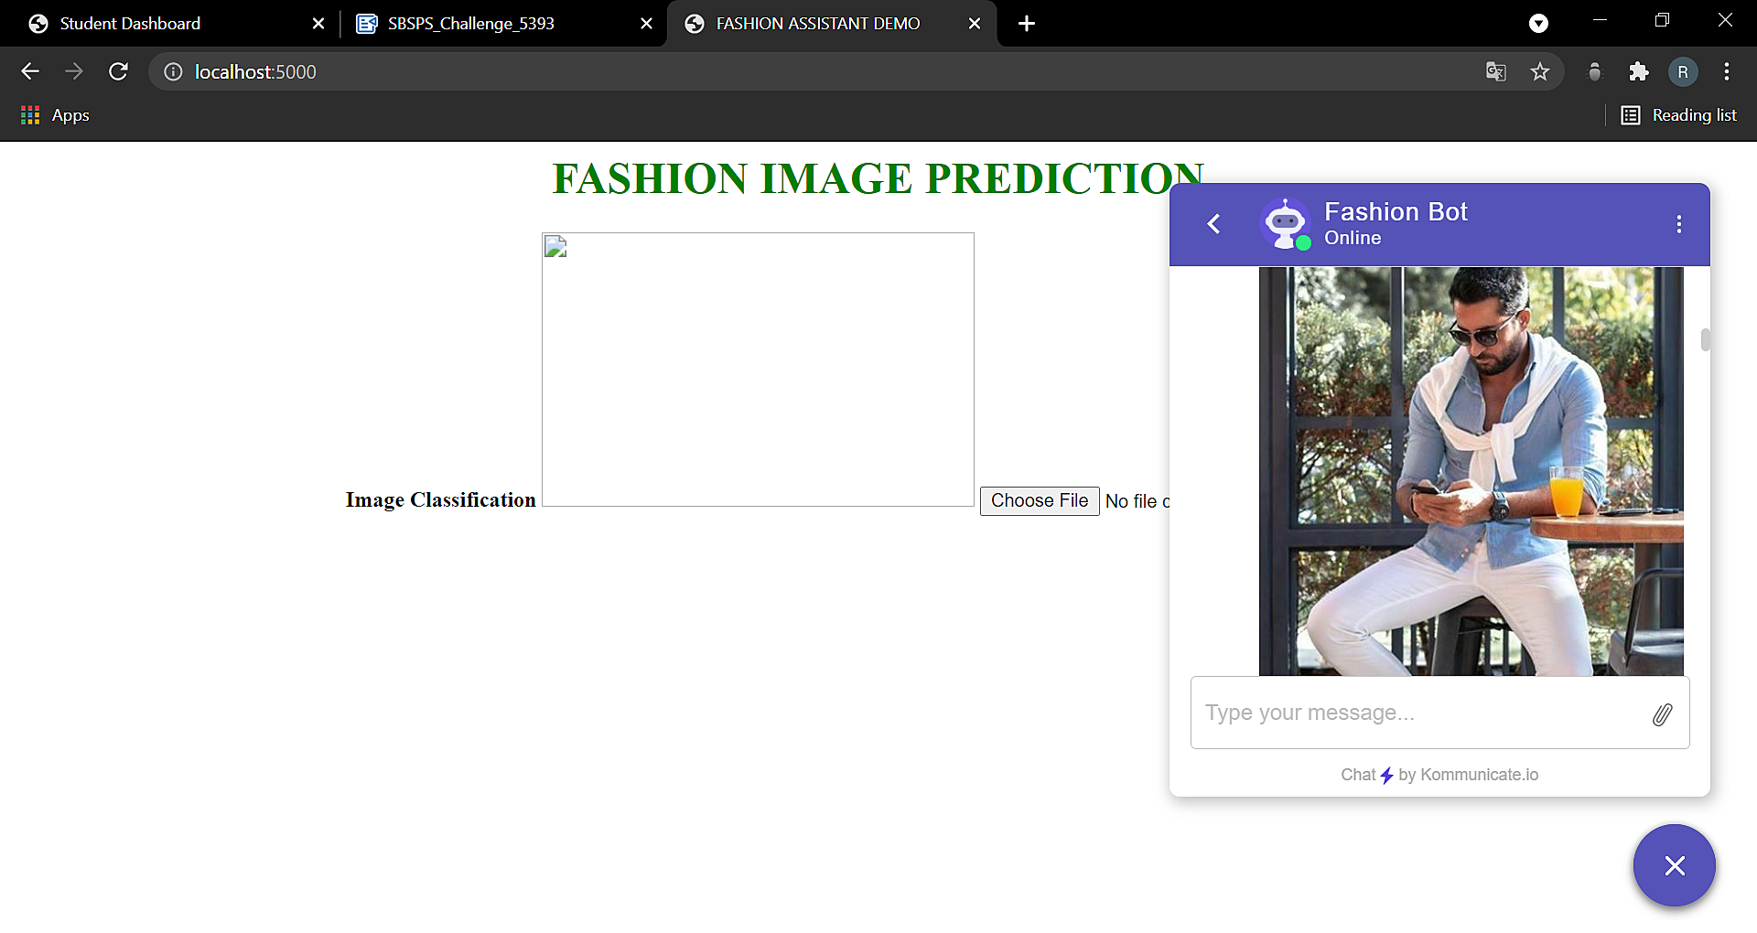

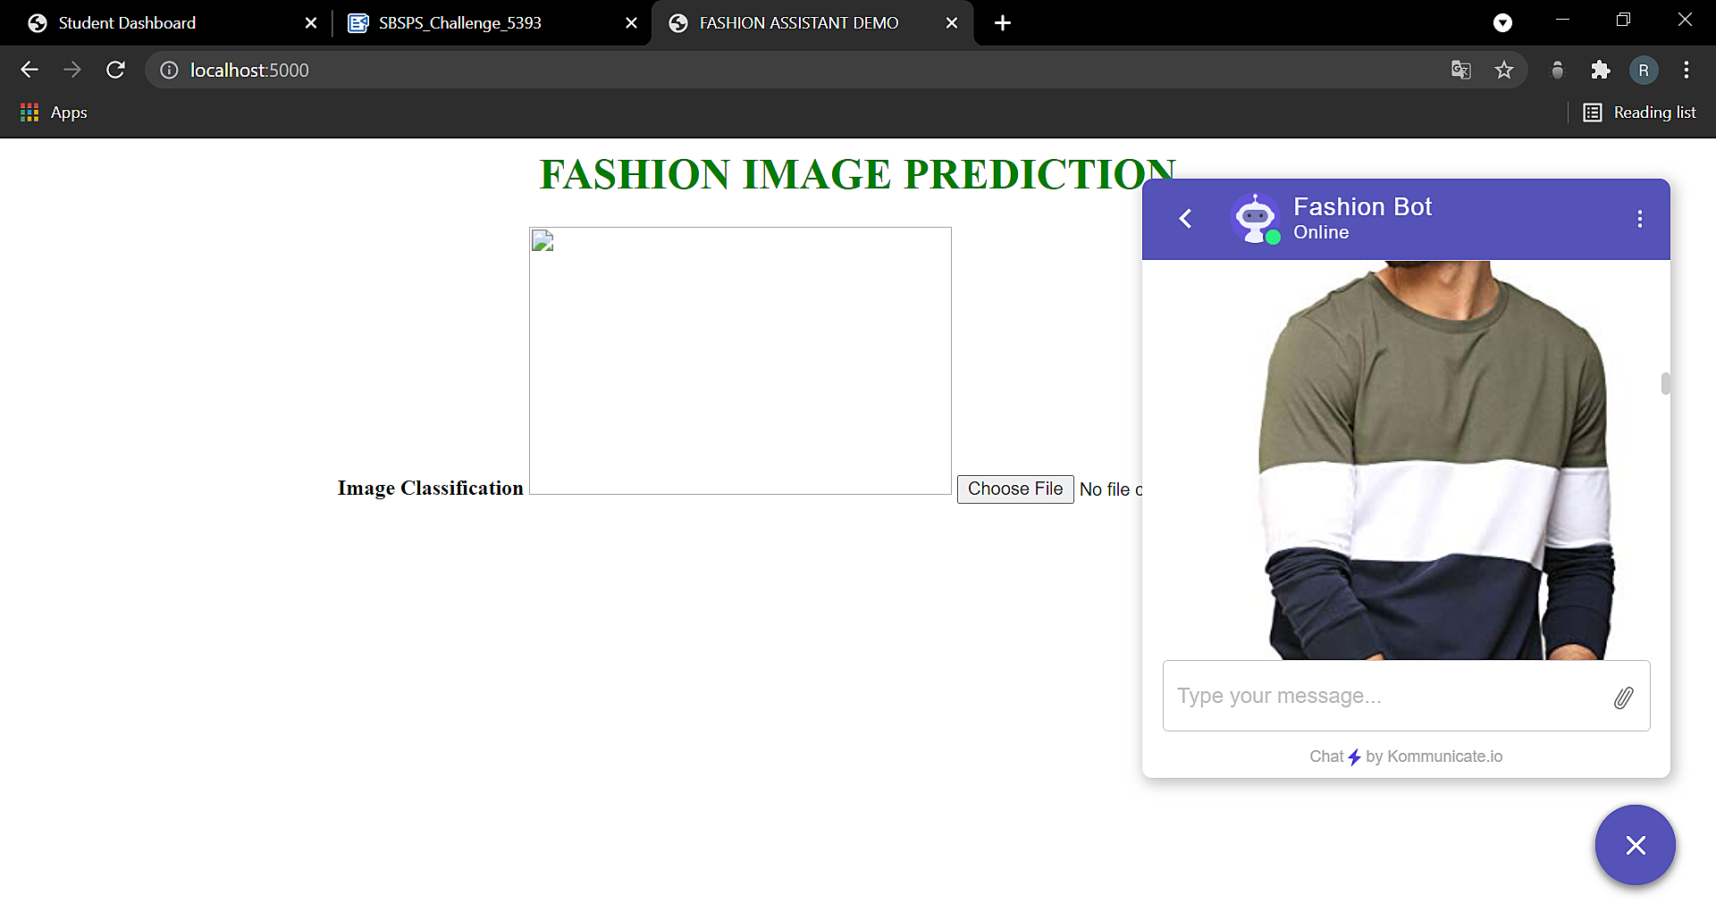

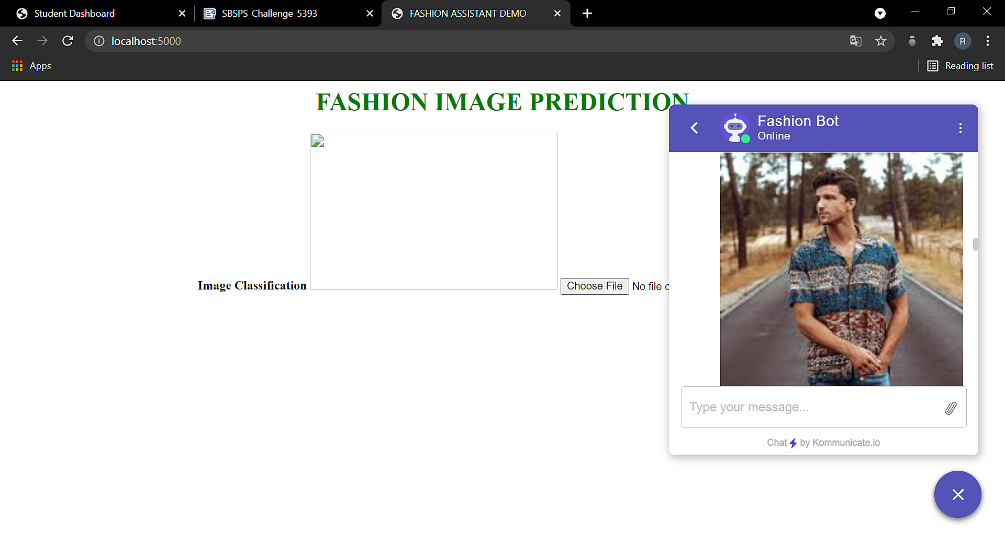

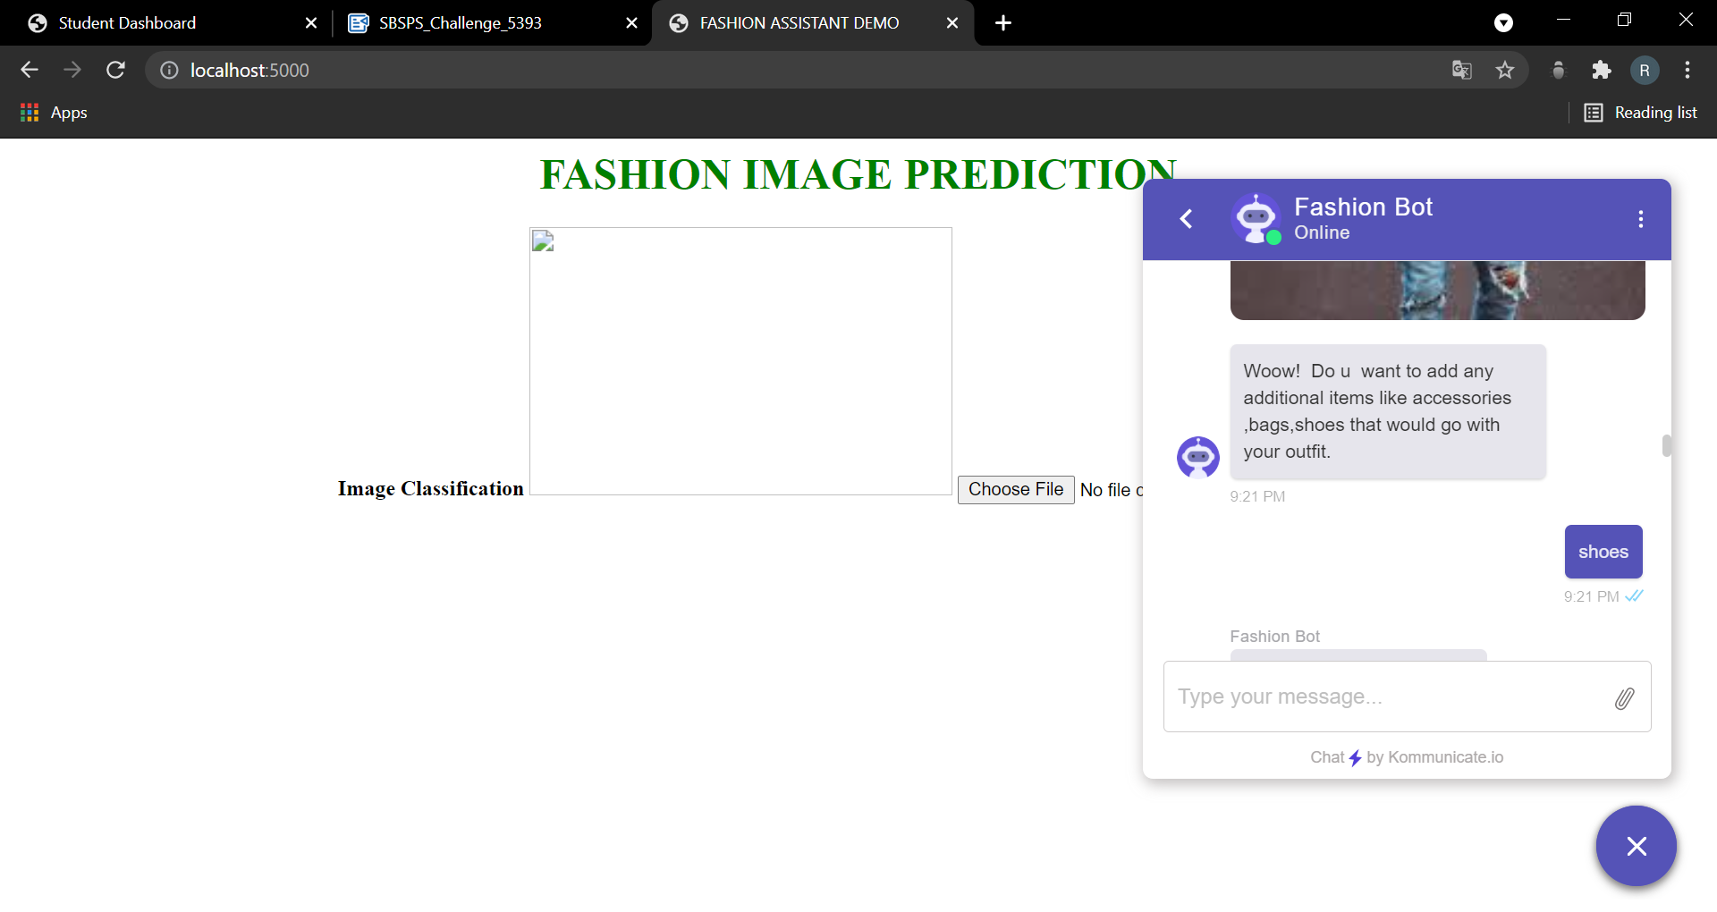

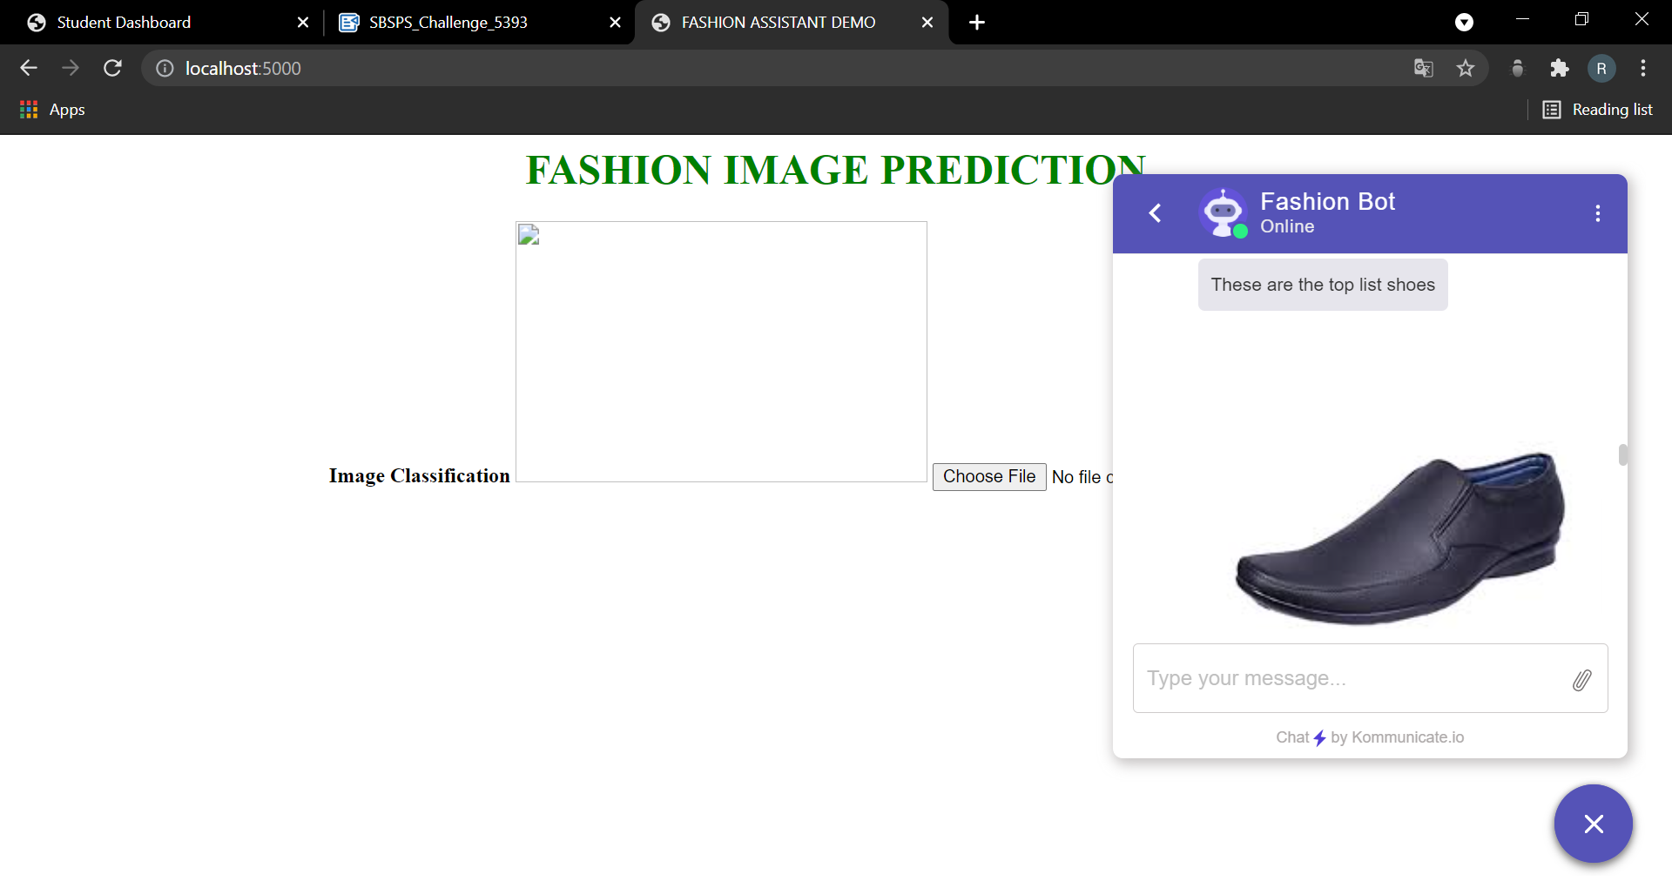

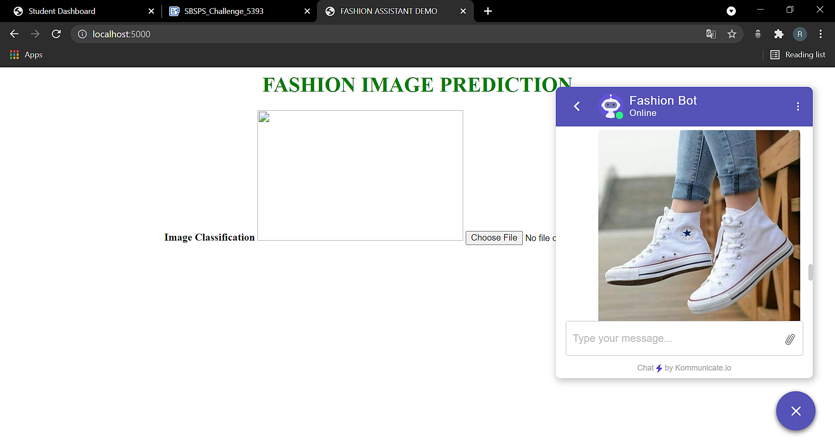

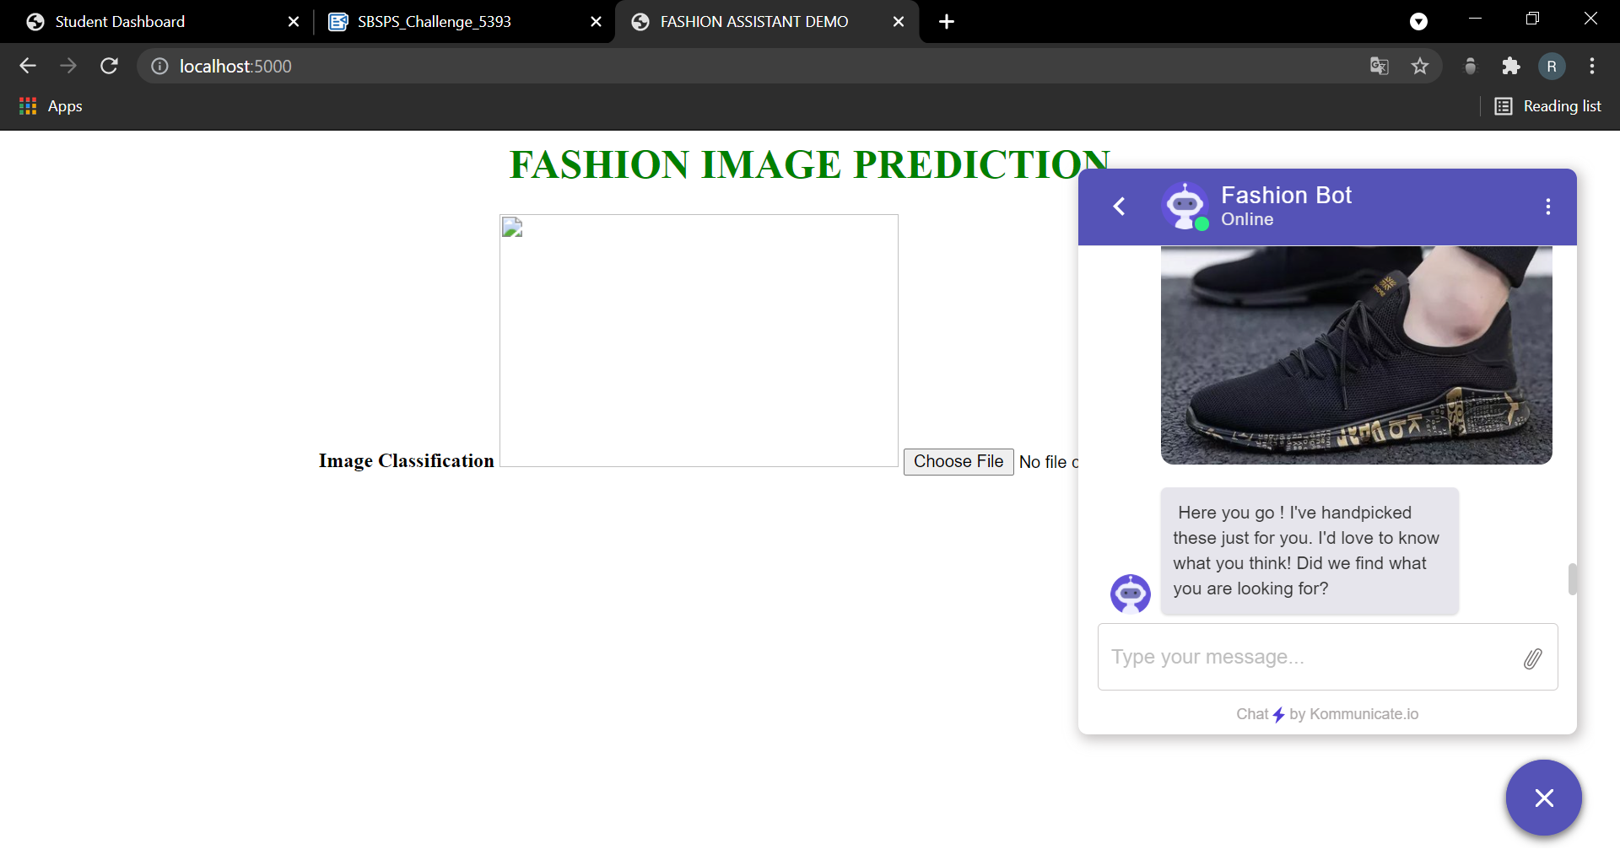

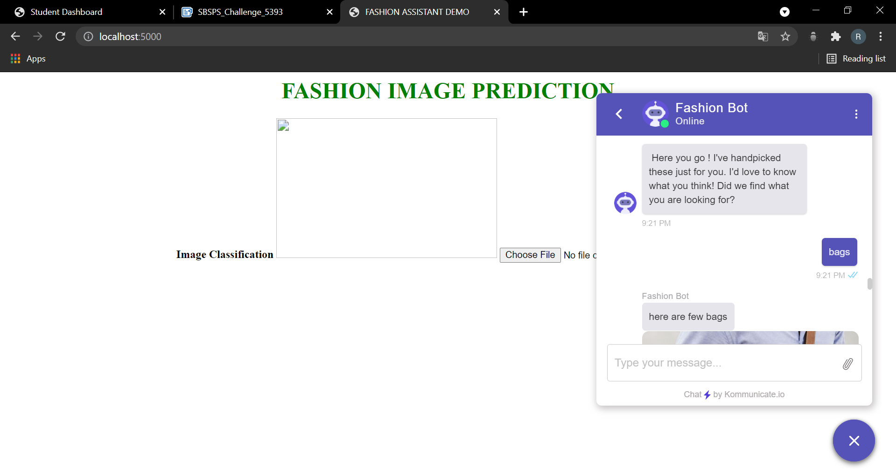

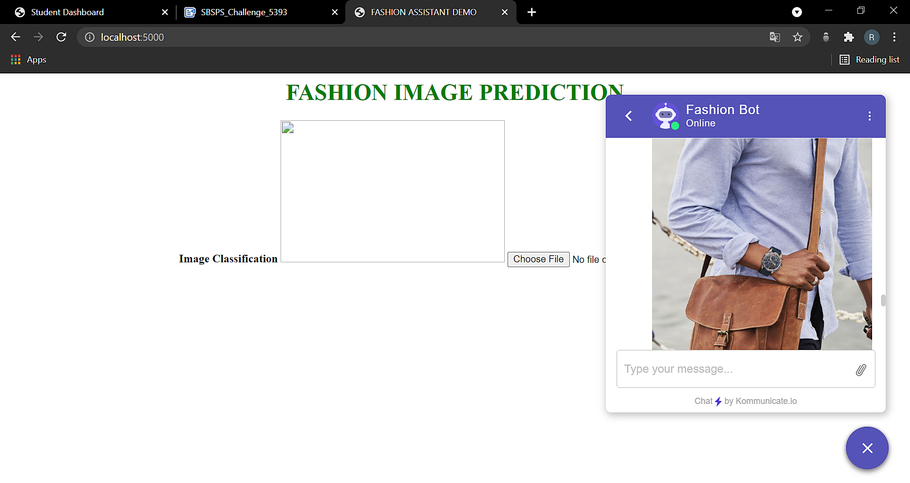

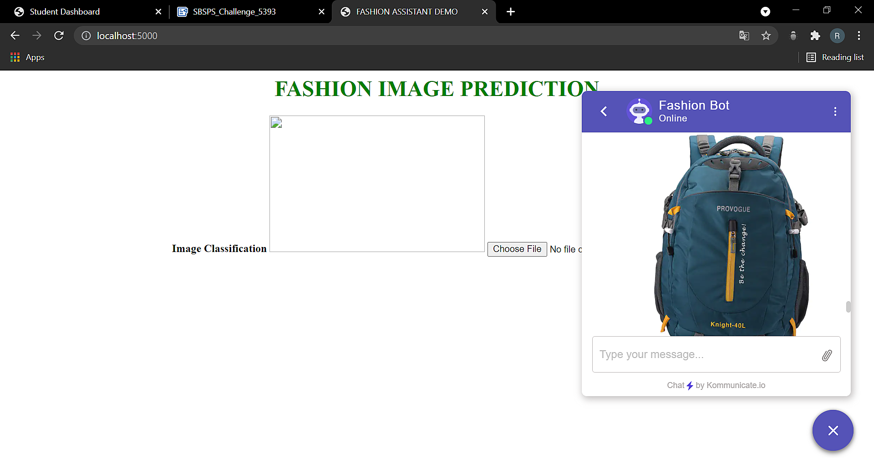

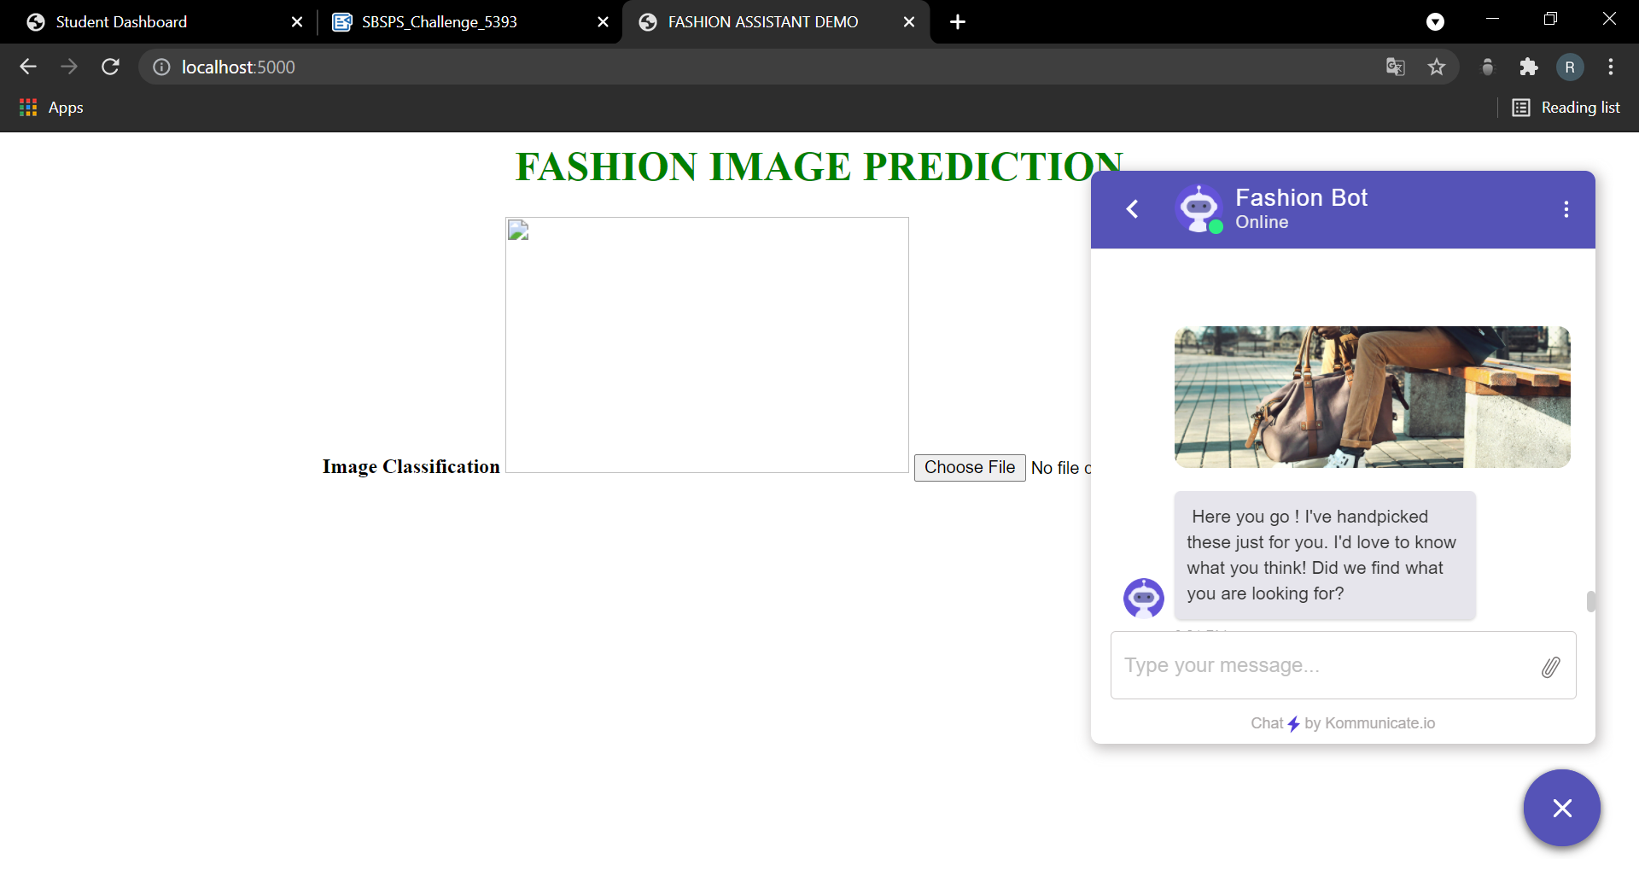

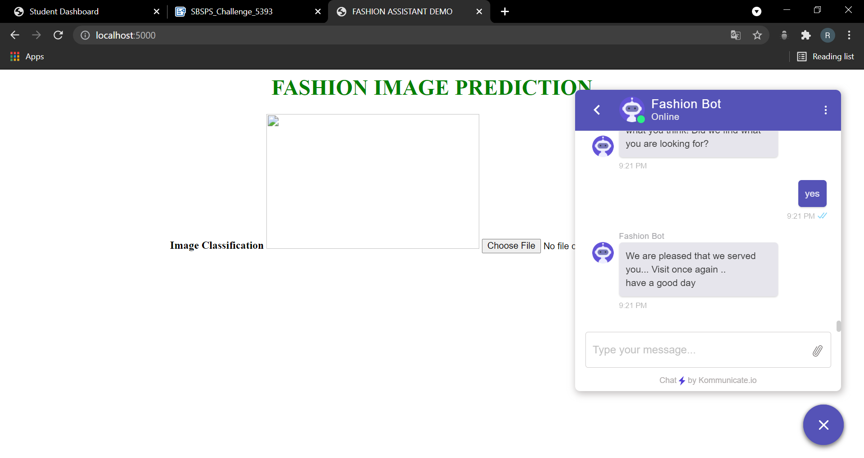

**ADVANTAGES OF PROPOSED SOLUTION:**

### 1. They help you get to know your customers

Conversational bots can help you get to know your customers even more. They let you figure out what their questions and needs are, plus the products recommendation they're interested in, and help you make strategic decisions to improve the experience.

### 2. They're a selling machine

Your bot can be the perfect partner to promote new products and send proactive notifications. They can also offer immediate assistance to your potential

3. **Customer service at any time**

One of the greatest advantages is that bots are available 24/7 to help customers. Plus, they respond quickly to every question they receive. This guarantees your customers will always be able to solve their problems, no matter what time of day.

### 4. They help optimize costs

Imagine your agents spending more time answering just the queries that require a human being. Implementing a bot with conversational AI is a great way to automate customer service and improve the service provided by agents, leading to cost optimization in the medium term.

### 5. They improve customer satisfaction

People are all different, and so is the way they communicate. That's why it's important to offer the appropriate and empathic answer to each query. For example, our conversational AI can understand informal language and regionalisms, improve conversations with plug-ins, and recognize the intent behind each interaction.

**DISADVANTAGES OF PROPOSED SOLUTION:**

* The user will only be able to make use of the recommendations provided by the bot , but the option for buying the item which they want is a bit difficult task in this proposed solution.

**CONCLUSION:**

Fashion is an important aspect of our everyday lives, what we wear tells the story of who we are and where we come from and who we want to be. People sometimes find it really hard to decide what to wear and what is suitable for their particular look and traits. The use of this project is to help with this issue using AI technology to create a real time chatbot that will help the user decide what to wear based on their looks and needs.

**FUTURE SCOPE:**

The proposed system can be deployed in many online shopping applications,so the user will be able to get the outfit which was recommended by the fashion assistant in that particular shopping application and simultaneously they will be able to access them easily.

**BIBLIOGRAPHY:**

* Kommunicate Bot integrations.
* kaggle

**Appendix:**

**Source Code for chatbot integration with webpage(FINAL OUTCOME):** https://drive.google.com/drive/folders/1jheRpeaQgoAd20qyp1NHmHJyexqkE-L7?usp=sharing